CraQ
A Crack Quantification tool from 2D image analysis
(or a way to colour the “grey” side of the geoscience)
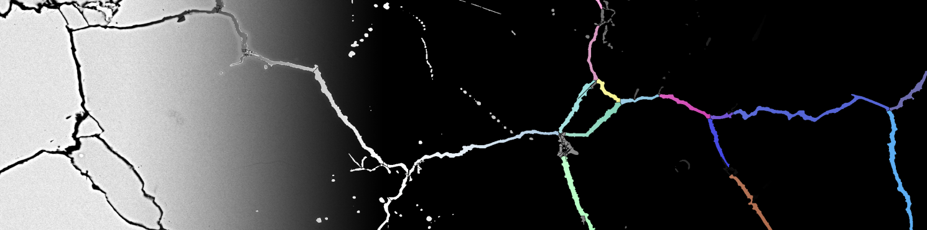
Conceived, designed and developed by Alessio Arena

Index
Before starting..........................................................................................2
Introducing the Graphic User Interface......................................................2
A brief tutorial...........................................................................................3
MergeNPlot external utility........................................................................7
Troubleshoot.............................................................................................7
About the source code...............................................................................8
About the source code...................................................................................8
Contact Details...........................................................................................8

Before starting
- Chose the proper version of the software (32bit or 64bit); if you don’t know which version of Windows you have, go to C: and check how many Programs folders you have; if you have two of them (Programs and Programs (x86)), then your version is 64bit.
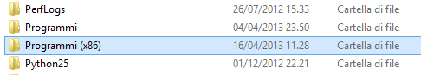
- Install the Matlab Compiler Runtime (MCRInstaller.exe), provided with the software
- This software uses parallel computing methodologies, provided into the Matlab® environment by the Parallel Computing toolbox; the program was tested using different computers and should work correctly. If you expect some problem related to this topic, please check the troubleshoot section of this guide

Introducing the Graphic User Interface
This program uses a GUI designed in purpose.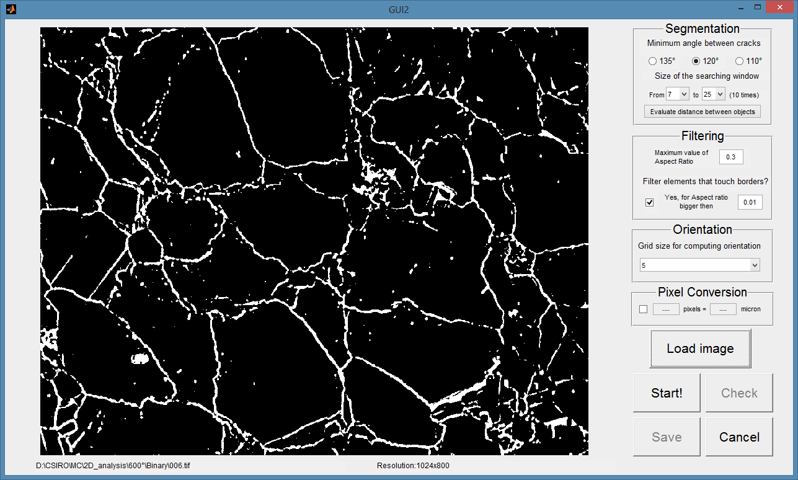
- The central area is dedicated to the original binary image you load
- The bottom area is used to show some basic informations, like the path of the image (usefull to check which image you analyzed) and its dimension
- On the right you can find all the GUI objects you have use to interact with the script.
- In addition this program was compiled as Console Application; this means that the executable will be open in a DOS environment, virtually Linux/Unix compatible (not tested). The black command window is used as Matlab Command window to show errors and additional informations

A brief tutorial
The first thing to do is load the image. This should be a binary image (1 bit), and the most common extensions are supported (*.jpg;*.bmp;*.tif;*.png;*.gif). Therefore I suggest working with bitmap uncompressed image.
To perform this operation just click the Load image button, and select the file from the selection window.
If the image has a very low resolution, a window will pop up, and you will have the choice to resize the dataset doubling its dimension; no interpolation will be performed.
Now you should be able to display it into the GUI.

Before launch the analysis we have to set up the parameters. Are there are some hints:
- Minimum angle between cracks. It’s a parameter mainly used for nodes with only two branches: if the angle between them is bigger than this value, the node is considered false and ignored. The default value is 120°, and it is the one extensively tested.
Values are limited to 135°, 120° and 110° due to the low angular resolution you can have with these kinds of datasets.
- Range of size of the searching window: These two values depend on the image resolution and the objects of the analysis performed.
To help choosing them you can use the evaluation utility. This estimate the distance between white pixels, giving you the results in “percentage of objects closer than”. Your maximum value you should be close or minor than the first two (corresponding to 20% and 30%).
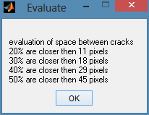
If you are going to perform more than one operation, the script will be run using a multicore methodology.
- Maximum value of aspect ratio. Used to filter results; if you don’t want any filter, use a value of 1
However a filtering based on a minimum area will be performed
- Border Kill module. You can filter objects touching borders: if you want to filter all of them choose 0; if you don’t want to filter them uncheck this box; otherwise you can filter them based on a minimum aspect ratio (use it carefully!)
- Grid size for the orientation module. Used to approximate cracks to polylines: low values mean a better approximation, but longer processing time.
- Pixel conversion. This program can perform a pixel->micron conversion; if you resized the image you have to double your “micron” value.

Now you can launch the script using the Start! Button. You can follow the progress using the command window
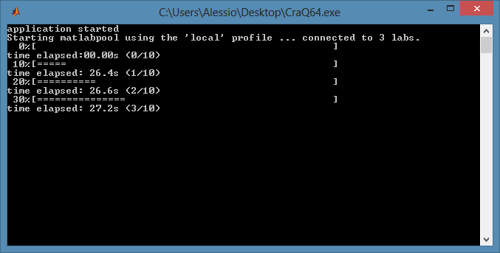

Once it’s done, if the script performed more than one operation, you have to choose the size of the searching window you want to use for the analysis. In this case a window will pop up, displaying two graphs:
- On the left you have the total number of objects found vs. the sizes attempted. The blue line represents numbers before the filter, while the green line is built using the values after the filter
- On the right you have the relative increase of number of object vs. the sizes attempted. As the previous graph you have two lines
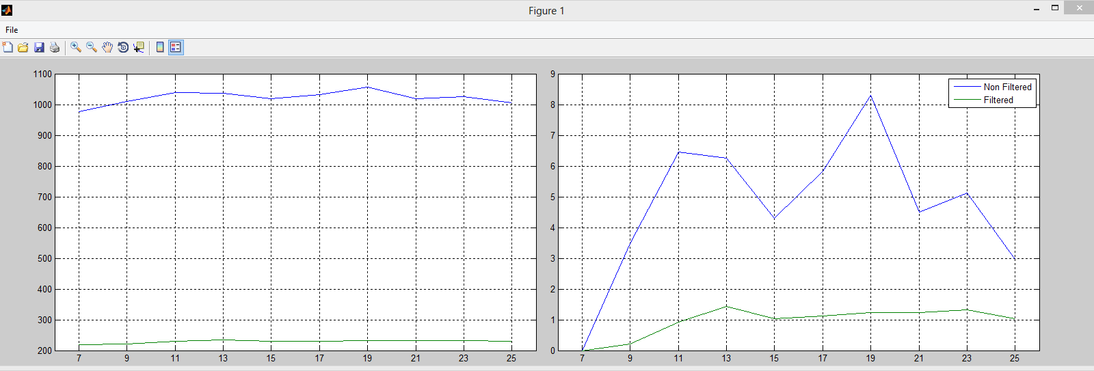

To choose the right value I suggest using mainly the figure on the right. In this graph you have to identify the points in which you have a (more or less) constant value of Non Filtered elements, and simultaneously the biggest number of Filtered elements. In the proposed example we find this situation using a size of 13.
Other interesting case could be the 15 and 21, in which we have the best ratio Filtered/Non Filtered.
However you have to choose this value keeping in mind the characteristics of your image, like noise, presence of pore and local density of cracks; the evaluation utility could be of help as well.
Once this value is chosen, you have to insert it in the dedicated window, and the program will finish the analysis.

At the end of the operation three windows will pop up, displaying the B/W image plus filtered elements in red, the labelled image (colour assignment is totally random), and a figure containing all results from the statistical analysis. In addition a function that calls individual results is linked with the labelled image, and can be activated using the data cursor button.
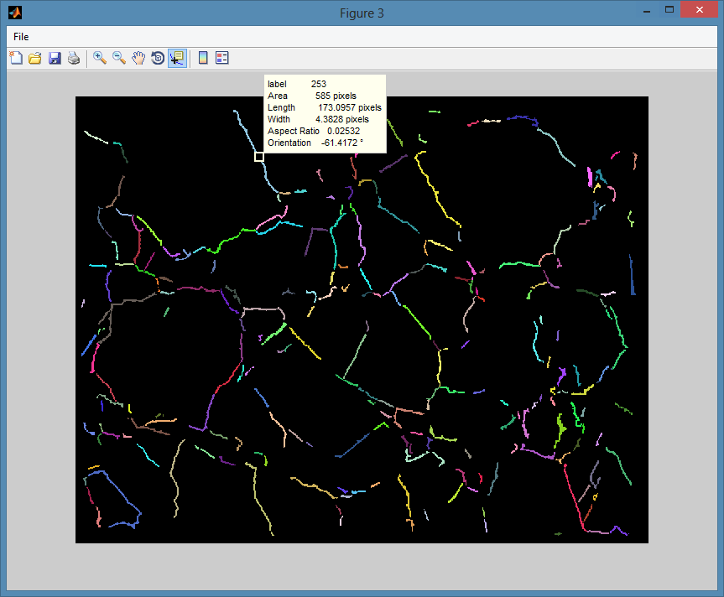
If you want to manually delete some objects, you can do that using the Check button in the main GUI. This will launch another small GUI used to create a list of unwanted objects, and then delete them and import results in the main program. At the beginning of this operation all the windows will be automatically closed, except of the main GUI and the labelled image used to select objects through the data cursor. Instead once you press the Compute and import button, all data will be reprocessed and analysed statistically.

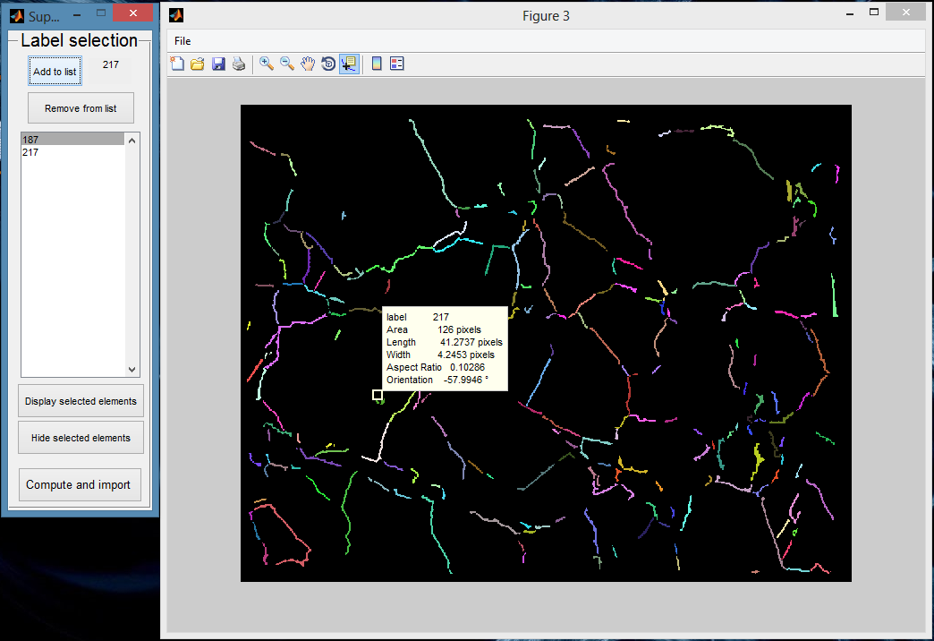

In the Label selection GUI there are other two buttons: the former, Display selected elements, will color objects on the list in white, while the latter, Hide selected elements, will colour them in black as the background. However is just a way to display them, and is reversible in every moment.
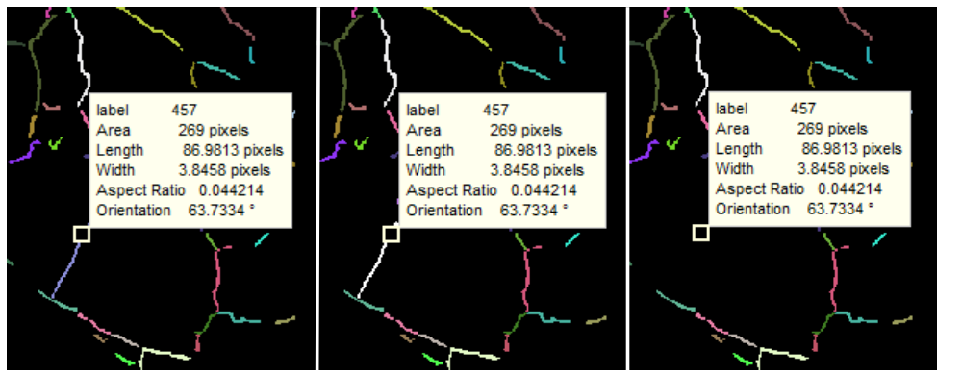

Finally, if you are satisfied about the analysis, you can save results. To perform this operation just press the Save button in the main GUI, and a new GUI, called SavinGUI will be launched.
Through this interface you can select the path in which you want to save results. You can chose you path for all the files, or individually change the directory and the name of all the files.
Individual parameters will be saved in a textual file formatted as CSV (Comma Separated Value), and you can import this in Excel. Other files will be saved as uncompressed bitmap.
In addition with the Labelled image, a Matlab file (.mat) will be created; this can be used in Matlab to perform other operations, or simply to check results individually once the program is closed.
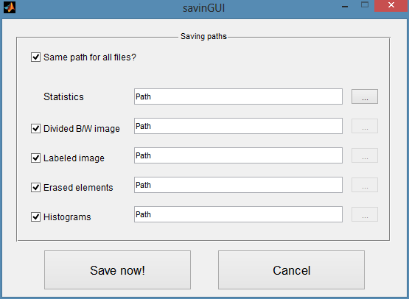

However the function associated with the data cursor is not embedded in the image, so you have to select manually the object. This is an example of code you can use to perform this operation:
>> N= inputdlg('Which object do you want to check?','ID Value');
>> n=str2double(N{1});
>> idx=find(lab==n);
>> size=inputdlg({'what is the size of the images?','x'},'size',1, {'3072','4096'});
>> a=str2double(size{1});
>> b=str2double(size{2});
>> check=zeros (a,b);
>> check(idx)=1;
>> figure, imshow(check);

MergeNPlot external utility
If you are performing a series of image analysis acquired from the same sample, maybe you want to merge your result and have a look to them from a statistical point of view.
This utility is what you are searching! Using a series of windows and basic GUI elements, you can interact with this simple script; this will merge your stats.txt files plotting histograms and results in a figure, just in the way the main program does.

Troubleshoot
- I’m expecting problems with the parallel computing feature
- I cannot load the stats.txt file into Excel
- I want to stop the analysis, but the script is running and the Cancel button doesn’t work

I’m expecting problems with the parallel computing feature
This program was developed for being used with a multicore computer, with at least 4 cores (now the standard). If you have a solution with less than 4 cores, this could be not working.
First thing to check is how many cores you have. In Windows this could be done opening the Performance tab in Task Manager, or using the Resource monitor (located in the same page) and finally CPU tab;
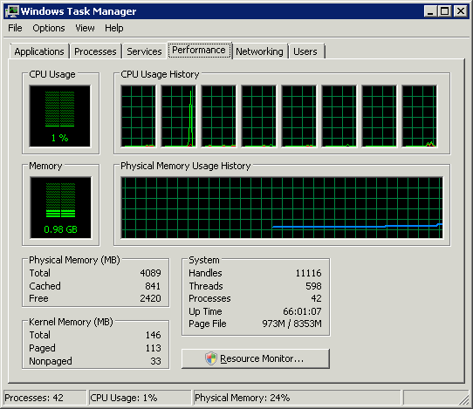
If you have more than 2 cores, probably you have just to set up properly you system. This operation requires Matlab installed.
Opening Matlab you can check the actual configuration, simply launching the command “parallel.cluster.Local”. I suggest you to use a number of workers equal to your number of cores less one (we still have to use the main Matlab process ).
Now you can set up your profile going in the Parallel menu (main Matlab), then Manage cluster profiles.
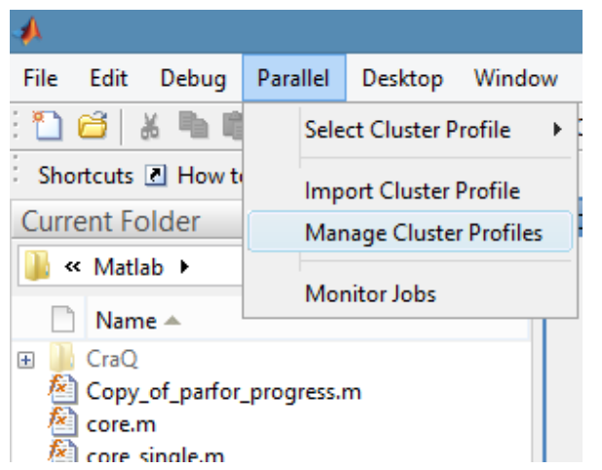

I cannot load the stats.txt file into Excel
If you receive an error saying something about the SYLK format when you try to load this file into excel, don’t worry!
The solution this time is easy. Try to load it a second time.

I want to stop the analysis, but the script is running and the Cancel button doesn’t work
Unfortunately there is no way to call the “brutal” cancel/stop using a button of a GUI.
Instead you can do it pressing CTRL+C, in the same way of Matlab

About the source code
The source code is provided only to be used directly in Matlab. To do this, launch the GUI.m function.
In the code you will not find comments and explanation (this is a form of protection of my work); if you want to modify or implement a part of this code, please contact me.
Please respect my work as I respect yours.

Acknowledgements
I want to thanks Claudio Delle Piane e Francesco Salvini for this great opportunity I had. Not only I was able to come in Australia, but I worked in a paradise for a geo and a curious person like me, full of toys and questions to be solved. I also want to thanks all my workmates, very smart people with different backgrounds, with whom I shared good conversations and exciting experiences.
You made me rich!

Contact Details
Alessio Arena
Email: alessio.arena@geologist.com

